OKID User Description:

This is a short description about the SI programs. It is based on OKID (Observer Kalman Filter Identification) using a covariance approach to reduce the noise influence. It is suited to analyze/id data or to simulate a system and than identify it. To start type Okid in the Matlab command line.

» okid
generate new data <1> or analyze data <2>: 1

The first quiry will be if you want to generate data or analyze (i.e. id some data you saved in a file. Let’s consider the first case: we generate data, type one, which will be acknowledged by the program by the following questions (example answers in black):

How many data points 1000
Sampling time TS: 0.025
Eigenvalues of true system:

ans =

-2.1425
-9.6837

noise yes <0>, no <1> :0

With this question you have the choice of generating process and measurement noise in the data generation process. The magnitude of noise is given by its standard deviation, which is specified by the next two inputs of the program:

standard deviation ratio of process noise [.01] =0.01
standard deviation ratio of measurement noise [.01] =0.01

Before finishing the data generation process, you have the option of saving the generated data. The default file name is called data.mat, so if you have already a file name by that, do change the default in the program called generate.m

save data file? yes <1>, no <0> :1

The parameters of the ARX model are next estimated. For that one needs to decide on the order of the model. The answer is not unique, use the program a lot for a known system so you get a feeling for the selection of ARX model order. This sounds not very scientific, but remember we deal here with a stochastic system.

order of ARX model(0=skip)Suggested value=15 15

The next question deals with the direct transmission matrix D in state space. Here, knowledge of the real live system is helpful (i.e. are sensors and actuators collocated?). To be save, choose D to be identified:

identify D?(1=yes,0=no) Suggested value=1 1

To construct the block-Hankel matrix and compute the Markov parameters, one needs to select how many are sufficient. A rule of thumb: use 2 – 3 times the number of ARX model parameters:
number of Markov parameters for ERA=(0=skip) Suggested value=45 45

The number of identified states can be determined from the singular values of the block Hankel matrix. The larger singular values are assumed to be associated with the system, the once with low magnitude are thought of to be due to noise in the system and measurement process. Use the figure generated by this program to determine the high Magnitude singular values:
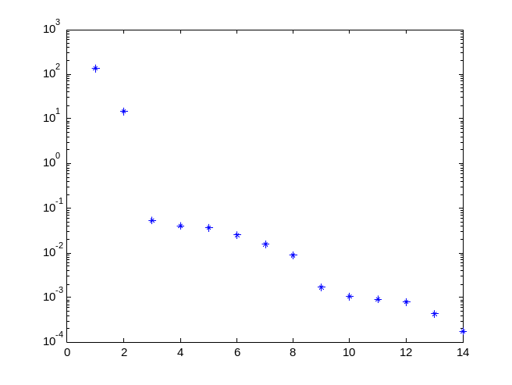
number of states of realized system (Suggested value=15): 2

The rest of the program gives information about the Kalman filter generated for the SI and the open – loop eigenvalues of the identified system. The results of the system model [Ai,Bi,Ci,Di] are in discrete time (with sampling time TS).

K =

0.1523
0.0290

Identified open-loop poles

mo =

-2.1310
-9.7884

If you want to use another analytical system, you need to change the state matrices in the file called generate.m.

For the second case, all is the same except that one needs to identify the file containing the data. Here is a sample run of this case:
» clear
» okid
generate new data <1> or analyze data <2>: 2
Data files: none
input name of .mat data file(Default=data): d
order of ARX model(0=skip)Suggested value=15 15
identify D?(1=yes,0=no) Suggested value=1 1
number of Markov parameters for ERA=(0=skip) Suggested value=45 45
number of states of realized system (Suggested value=15): 2

K =

0.1523
0.0290

Identified open-loop poles

mo =

-2.1310
-9.7884

»

